HUNGER AT HOME  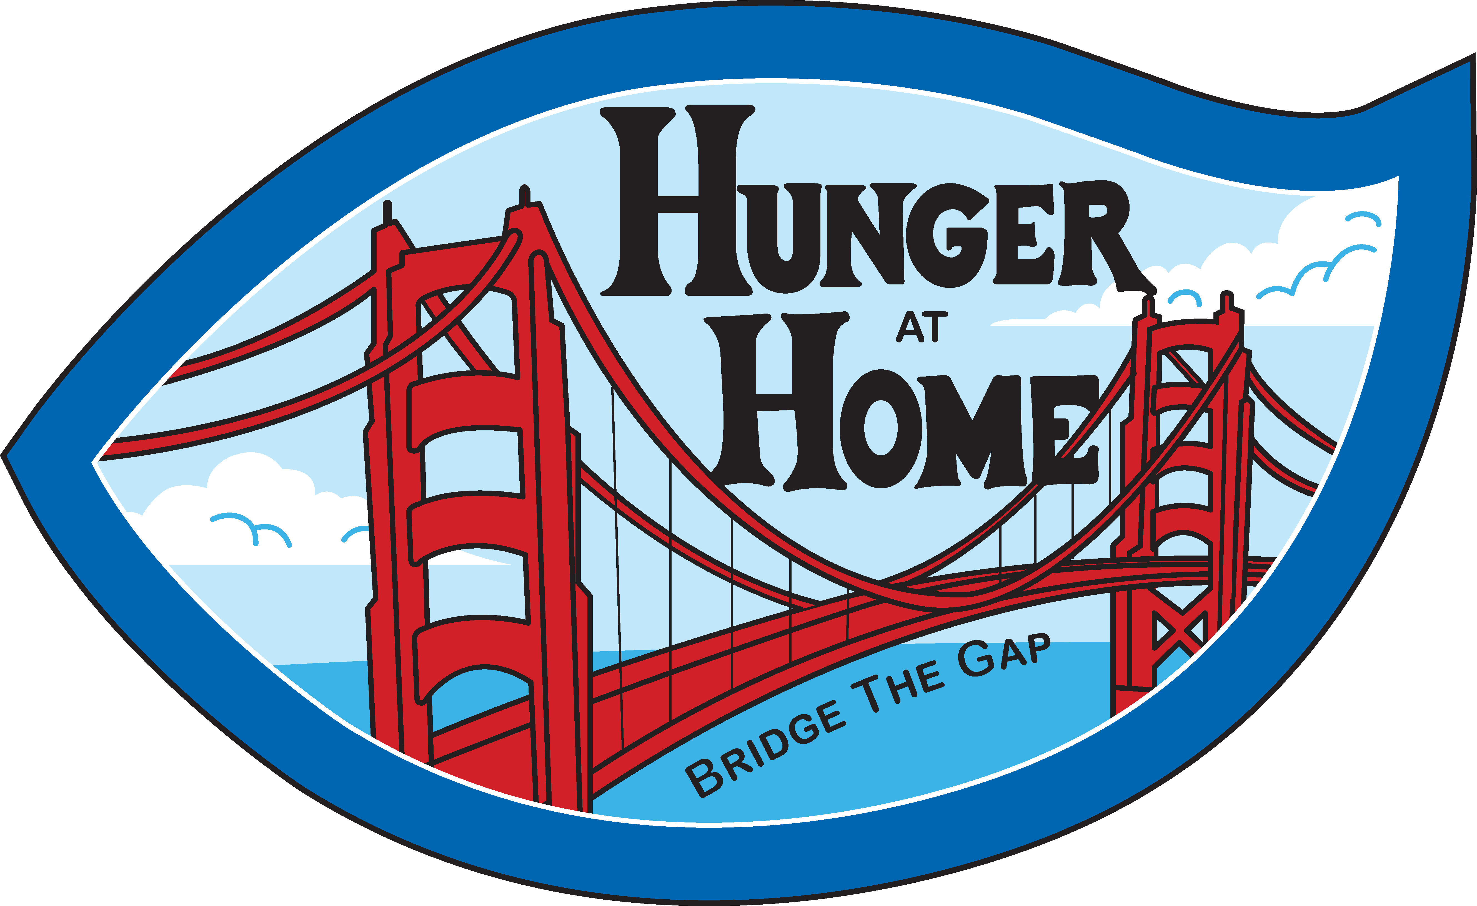  DRIVE THRU FOOD DISTRIBUTION  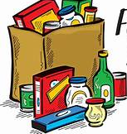  We will be loading up vehicles with many great products such as produce, mixed grocery boxes, snacks, and pre-made meals.  Join us for a Special Holiday Distribution on 12/24/2021 at  Lincoln Glen Church  2700 Booksin Ave  San Jose, CA 95125  December  2021  SUN MON TUE WED THU FRI SAT  1 2 3 4  5 6 7 8 9 10 11  12 13 14 15 16 17 18  19 20 21 22 23 24 Holiday Distribution 25  26 27 28 29 30 31 HAPPY NEW YEAR!!!! | Where  PayPal Park  1123 Coleman Ave  San Jose, CA  __________WHEN  See Calendar below  __________  TIME  9-11am  _________  Be sure to wear a mask and follow all social distancing protocols. Upon arrival, we require that you stay inside your vehicle at all times.  BE SAFE & STAY HEALTHY.  ___________  CONTACT HUNGER AT HOME 1560 Berger Drive  San Jose, CA 95112 (408)318-0038 www.hungerathome.org

