HUNGER AT HOME  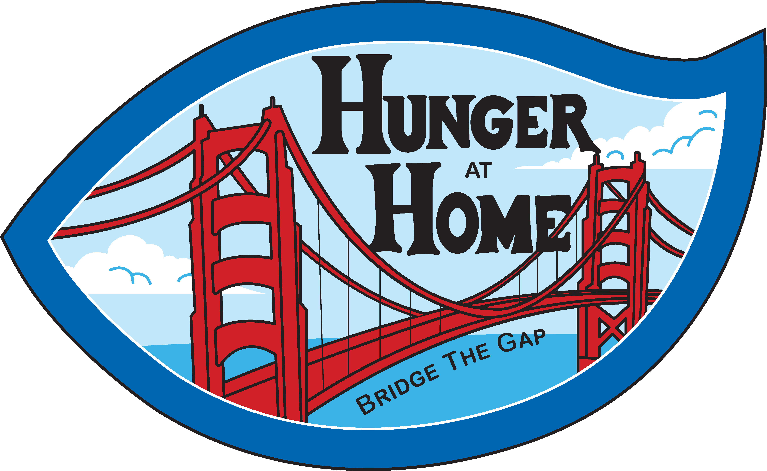  DRIVE THRU FOOD DISTRIBUTION  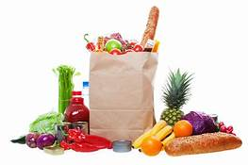  Your vehicle will be loaded with many great products including produce, mixed grocery boxes, bread, premade meals and much more.  2022 2022  Sun Mon Tue Wed Thu Fri Sat Sun Mon Tue Wed Thu Fri Sat  1 2 3 4 5 1 2 3 4 5  6 7 8 9 10 11 12 6 7 8 9 10 11 12  13 14 15 16 17 18 19 13 14 15 16 17 18 19  20 21 22 23 24 25 26 20 21 22 23 24 25 26  27 28 27 28 | Where  PayPal Park  1123 Coleman Ave San Jose, CA  WHEN  See calendar  _______  TIME  9am - 11am  _________  Be sure to wear a mask and follow all social distancing protocols.  Upon arrival, we require that you stay inside your vehicle at all times.  BE SAFE & STAY HEALTHY  _______________  CONTACT HUNGER AT HOME 1560 Berger Drive  San Jose, CA 95112  (408) 318-0038 www.hungerathome.org
People helping people

